# Department of Computing

**CS344: Web Engineering**

**Class: BSCS – 5AB**

# Lab 3: Image browser and Use of CSS.

**Date: Mar 02, 2017**

# Instructor: Dr. Asad Ali Shah

# Lab Engineer: Qasim Ali Khan

Contents

Department of Computing 1

Lab 3: Image Browser 1

Instructor: Dr. Asad Ali Shah 1

Lab Engineer: Qasim Ali Khan 1

Lab 3: Responsive Image browser 3

Introduction 3

Objectives 3

Tools/Software Requirement 3

Pitfalls 3

Deliverables 3

Hint 3

# 

# Lab 3

## Lab Task # 1

Find the document attached

http://citeseerx.ist.psu.edu/viewdoc/download?doi=10.1.1.110.2940&rep=rep1&type=pdf

Description: You are required to convert the following pdf into an HTML document with the following requirements

* All Main headings like Abstract, Introduction should be in a div container with red background.
* All Sub headings like 2.1, 2.2 should be in another div container with blue background
* All text should be justify align with white text color and text size of 12
* Special CSS styling should be applied to Abstract heading, Its div container color should be orange and its text should be back and italics and a text size of 10.
* Special CSS styling should be applied to References heading. Its text size should be 10
* The title and author affiliations needs to be center aligned and text size of 26

# Task # 2 : Responsive Image browser

## Introduction

In this lab, students will create a web based image browser & a basic document using only HTML5 and CSS3. Each student must, individually build the complete web application on their own. An image browser cab displays pictures from a folder with image name as captions. The user should be allowed to switch images, with at-most one image taking primary display space at a time. Students must upload their solutions on LMS to qualify for evaluation.

## Objectives

1. Create an Image Browser (using div tags, use display:none and display:block to hide or show content in div).
2. (plus point) Make it responsive (so it works with multiple screens, like pc, phone, tablets, etc)
3. The user should be able to switch between images (minimum 5).
4. **Example below:**

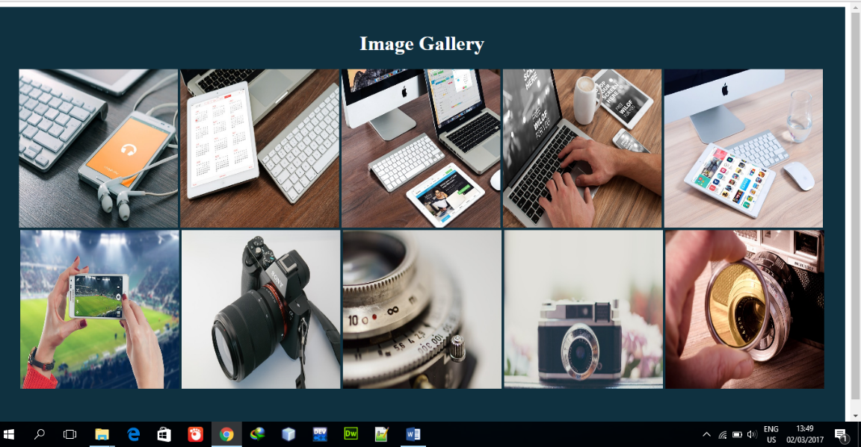

## Tools/Software Requirement

1. Students should implement their solutions using HTML5 and CSS3 only.
2. Besides LMS, Students must also use GitHub and upload their complete solutions and a description document on it. Pitfalls

* Any exceptions or errors leading to non-execution of submitted code.
* Using Javascript or any other scripting language, besides HTML5 and CSS3
* Failure to display multiple browse-able images.
* Displaying all the images on the page at one time.
* Failure to explain the submission, during viva.

## Deliverables

Students must upload the following LMS:

1. Description document.
2. All source code.

## Hint for responsive design

https://www.w3schools.com/Css/css_rwd_images.asp